Experiment 2:
Operators
Name- Rahul Mankani
SAP ID- 590014725
Batch- 38
Course Coordinator- Dr. Tanu Singh
- Write a C program to calculate the area and perimeter of a rectangle based on its length and width.
#include <stdio.h>
int main()
{
int x,y,area,perimeter;
printf("Enter the length of rectangle:\n");
scanf("%d",&x);
printf("Enter the breadth of rectangle:\n");
scanf("%d",&y);
area =(x*y);
perimeter =(2*(x+y));
printf("area:%d\n",area);
printf("perimeter:%d",perimeter);
return 0;
}
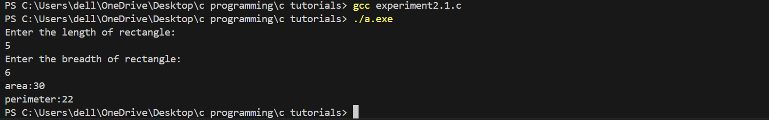
- Write a C program to Convert temperature from Celsius to Fahrenheit using the formula: F = (C * 9/5) + 32
#include <stdio.h>
int main()
{
float c,f;
printf("Enter temperature in celsius:\n");
scanf("%f",&c);
f=(c*(9.0/5.0)+32);
printf("Temperature in fahrenheit:%f\n",f);
return 0;
}
